LangChain AI Agent
Objectives, Code Explanation and Test Results
Prepared by: Amna Khurram
BS Data Science, University of Management and Technology (UMT), Lahore
August 2026

1. Objectives
The purpose of this project is to design and implement a simple, functional AI agent using the LangChain framework in Python. Unlike a standard chatbot, which only generates text responses, an agent is capable of reasoning about a request, selecting an appropriate tool when needed, executing that tool, and using its result to produce an accurate final answer.
The specific objectives of this project are:
- To build a working AI agent capable of autonomous tool selection and reasoning
- To integrate a large language model (LLM) via the Groq API as the agent's reasoning engine
- To equip the agent with a calculator tool for accurate arithmetic operations
- To equip the agent with a live web-search tool for retrieving current, real-world information
- To structure the code in a clean, professional, and maintainable format suitable for real-world use
- To test and validate the agent's ability to correctly choose between its available tools

2. Code Explanation
The complete agent was implemented in a single Python script, simple_langchain_agent.py. Its structure is explained section by section below.

2.1 Imports
import logging
from langchain_groq import ChatGroq
from langchain.agents import create_agent
from langchain_core.tools import tool
from langchain_community.tools import DuckDuckGoSearchRun
- logging — used for structured status and error messages instead of plain print statements
- ChatGroq — connects LangChain to Groq's hosted large language model
- create_agent — the LangChain function used to assemble the model and tools into a working agent
- tool — a decorator that turns a normal Python function into a tool the agent can call
- DuckDuckGoSearchRun — a ready-made, free web search utility

2.2 Configuration
GROQ_API_KEY = "YOUR_API_KEY_HERE"
MODEL_NAME = "openai/gpt-oss-120b"
TEMPERATURE = 0
All configurable values are grouped at the top of the file rather than scattered through the code. The temperature is set to 0 so the model behaves as consistently and predictably as possible, which is important for reliable tool-selection decisions.

2.3 The Language Model
def build_llm() -> ChatGroq:
"""Initialize and return the Groq-hosted language model."""
return ChatGroq(
model=MODEL_NAME,
temperature=TEMPERATURE,
groq_api_key=GROQ_API_KEY,
)
This function isolates model creation into a single, reusable unit, making the code easier to test and maintain.

2.4 The Calculator Tool
@tool
def calculator(expression: str) -> str:
"""Evaluate a basic arithmetic expression."""
if not all(char in _ALLOWED_CHARS for char in expression):
return "Invalid input: only numeric expressions are permitted."
try:
return str(eval(expression))
except Exception as exc:
return f"Could not evaluate expression: {exc}"
The docstring is not just documentation — the language model reads it to decide when this tool is relevant. A character whitelist is enforced before evaluation to prevent unsafe input from reaching Python's eval() function.

2.5 The Web Search Tool
@tool
def web_search(query: str) -> str:
"""Search the web for current or real-world information."""
return _search_engine.run(query)
This tool gives the agent access to live, real-world information — such as current weather or recent events — that a language model alone would not otherwise know.

2.6 Building and Running the Agent
def build_agent():
llm = build_llm()
return create_agent(llm, tools=[calculator, web_search])

def run_cli() -> None:
agent = build_agent()
while True:
user_input = input("You: ").strip()
if user_input.lower() == "exit":
break
response = agent.invoke({"messages": [{"role": "user", "content": user_input}]})
print("Agent:", response["messages"][-1].content)
The agent combines the language model and both tools into a single reasoning loop: it receives the user's message, decides whether a tool is required, calls that tool if needed, and produces a final answer based on the result.

3. Test Results
The agent was tested with two distinct types of queries to confirm that it correctly identifies which tool to use for a given request, rather than guessing or relying purely on the language model's internal knowledge.

3.1 Test 1 — Calculator Tool
Query: "125 * 8". The agent correctly identified this as an arithmetic operation, invoked the calculator tool, and returned the exact result.
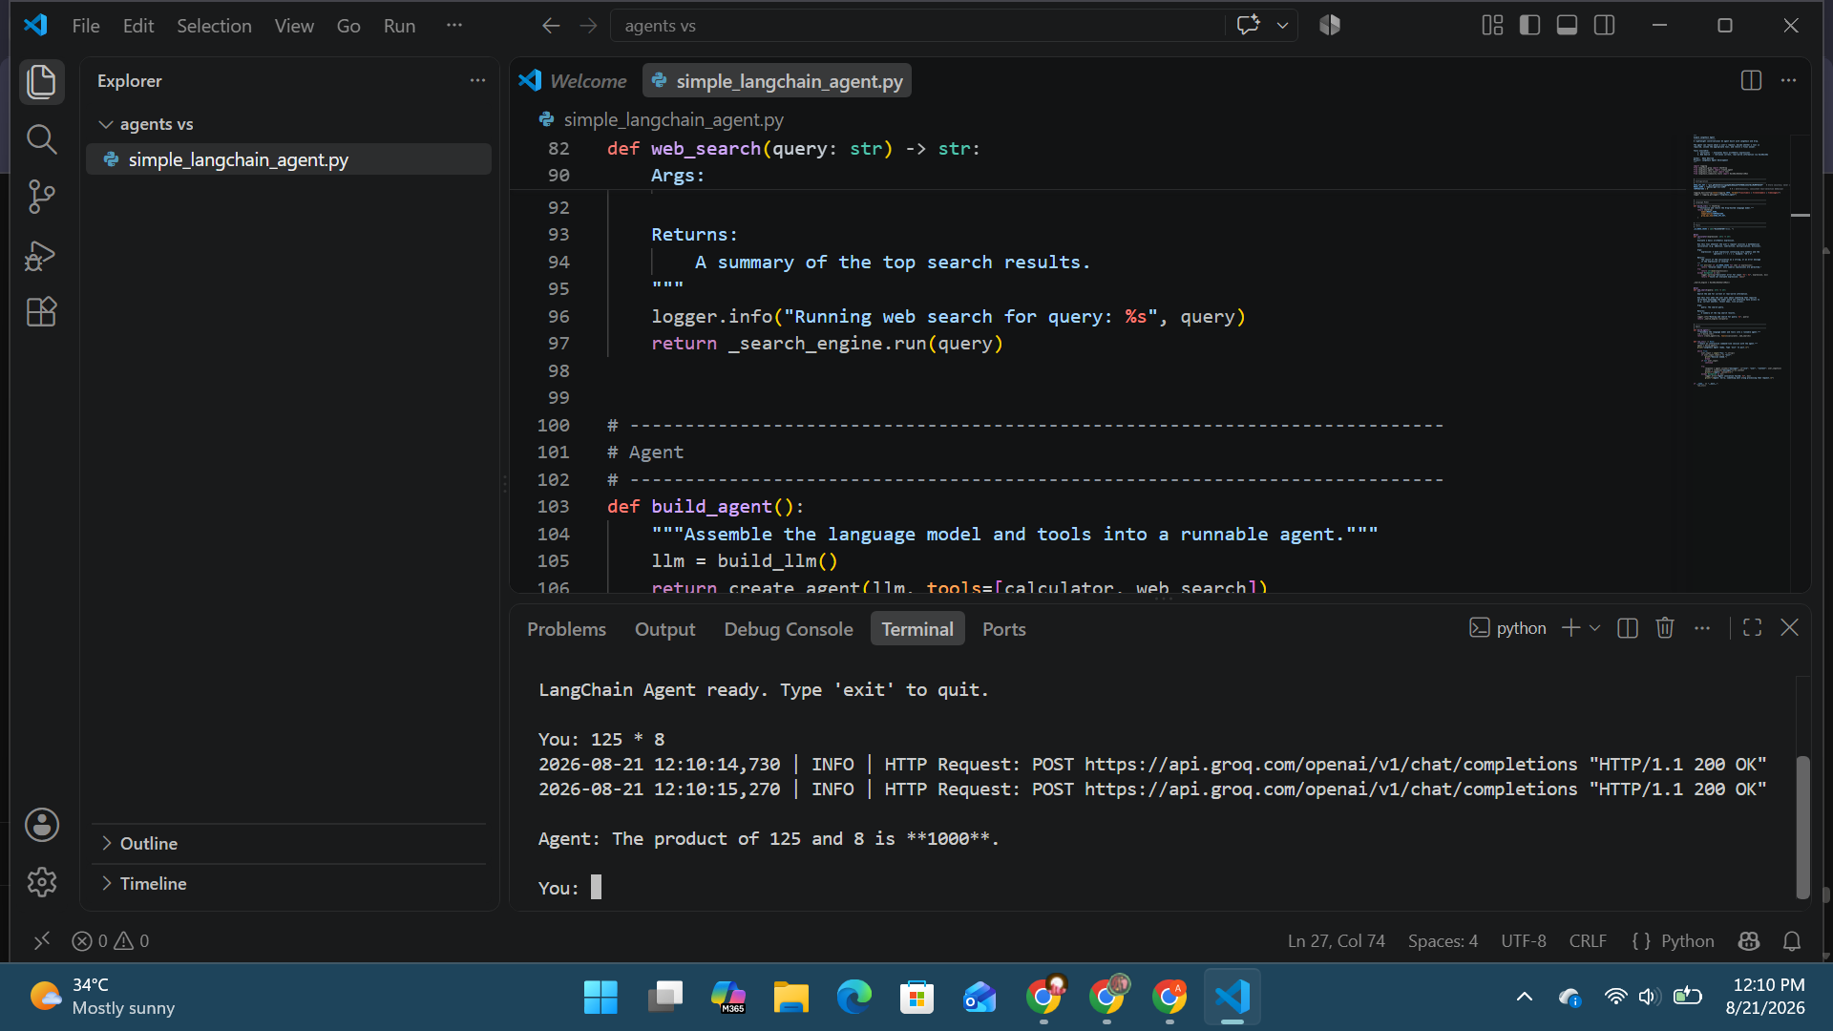
Figure 1: Agent correctly using the calculator tool

3.2 Test 2 — Web Search Tool
Query: "weather in Lahore". The agent recognized that this required current, real-world information and invoked the web-search tool. As shown below, the agent's underlying search process also demonstrated resilience: when one search engine returned a connection error, it automatically continued with an alternative source rather than failing outright.
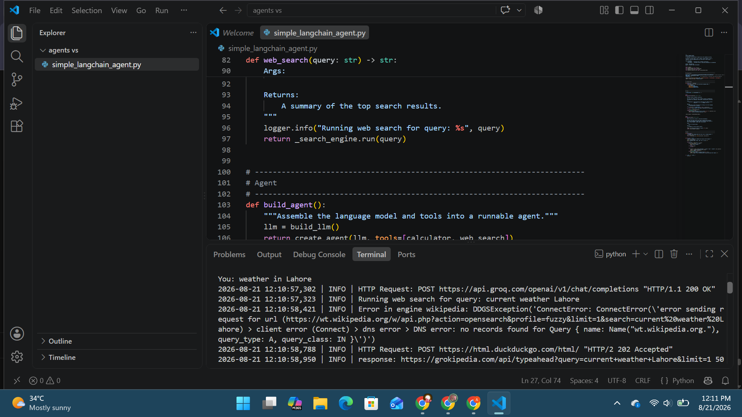
Figure 2: Agent invoking the web-search tool, with automatic fallback after an initial connection error
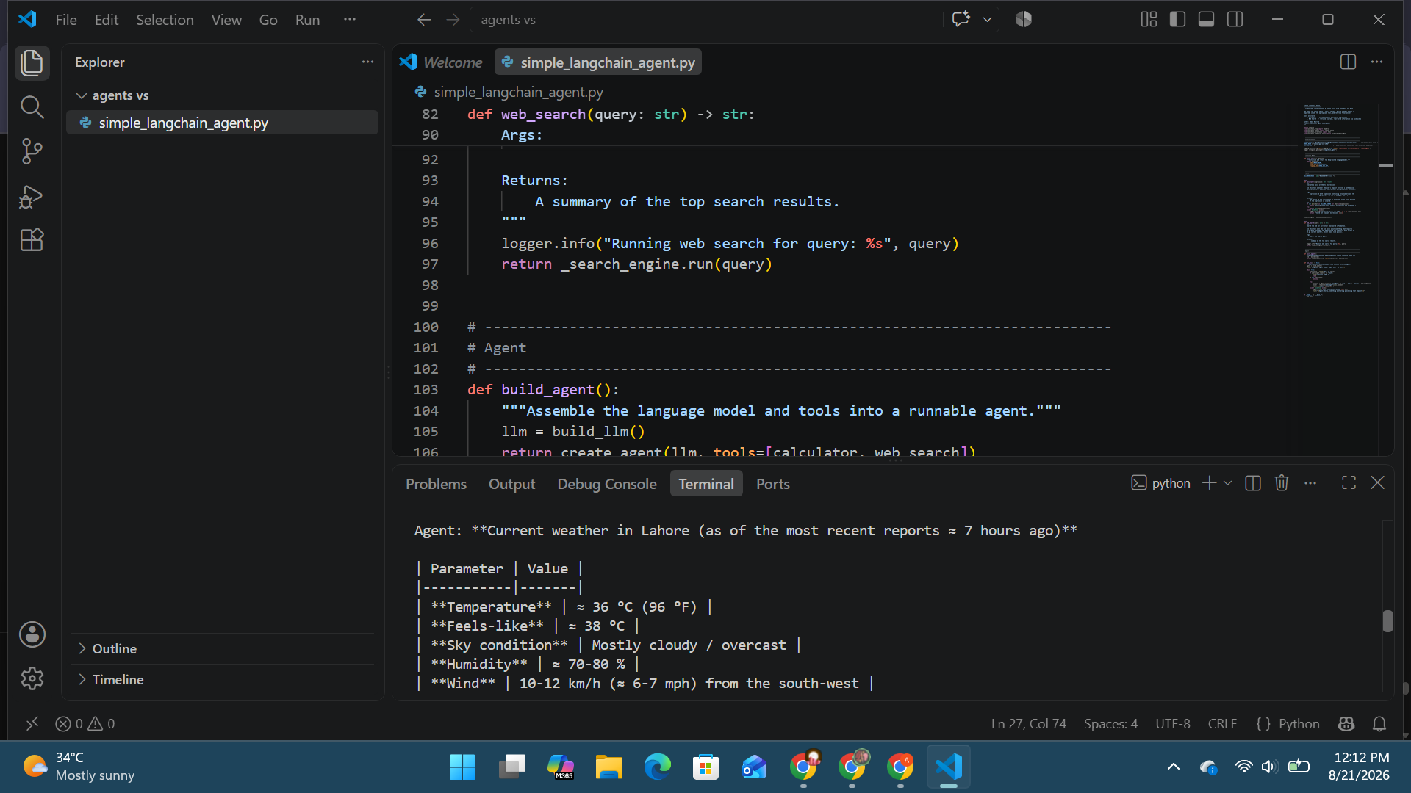
Figure 3: Agent returning a structured, well-formatted weather summary
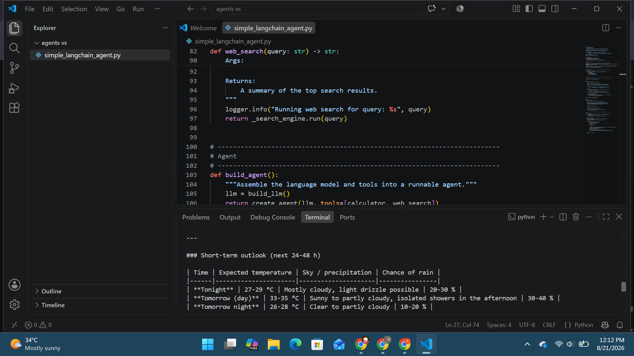
Figure 4: Agent providing practical, context-aware recommendations based on the search results
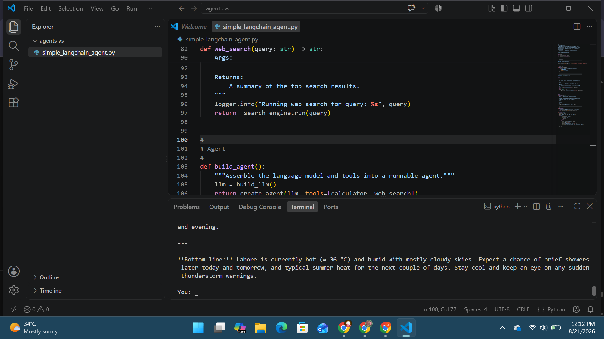
Figure 5: Agent's concluding summary, with the session ready for the next query

4. Conclusion
Both tests confirm that the agent meets its stated objectives: it reliably distinguishes between a mathematical request and a real-world information request, invokes the correct tool in each case, and returns a clear, well-structured, and accurate response.

